DevOps Basics

Definition : DevOps is a set of practices that combines software development (Dev) and IT operations (Ops). It aims to shorten the systems development life cycle and provide continuous delivery with high software quality.^{[1]} DevOps is complementary with Agile software development; several DevOps aspects came from the Agile methodology.

Devops : Who all are involved?

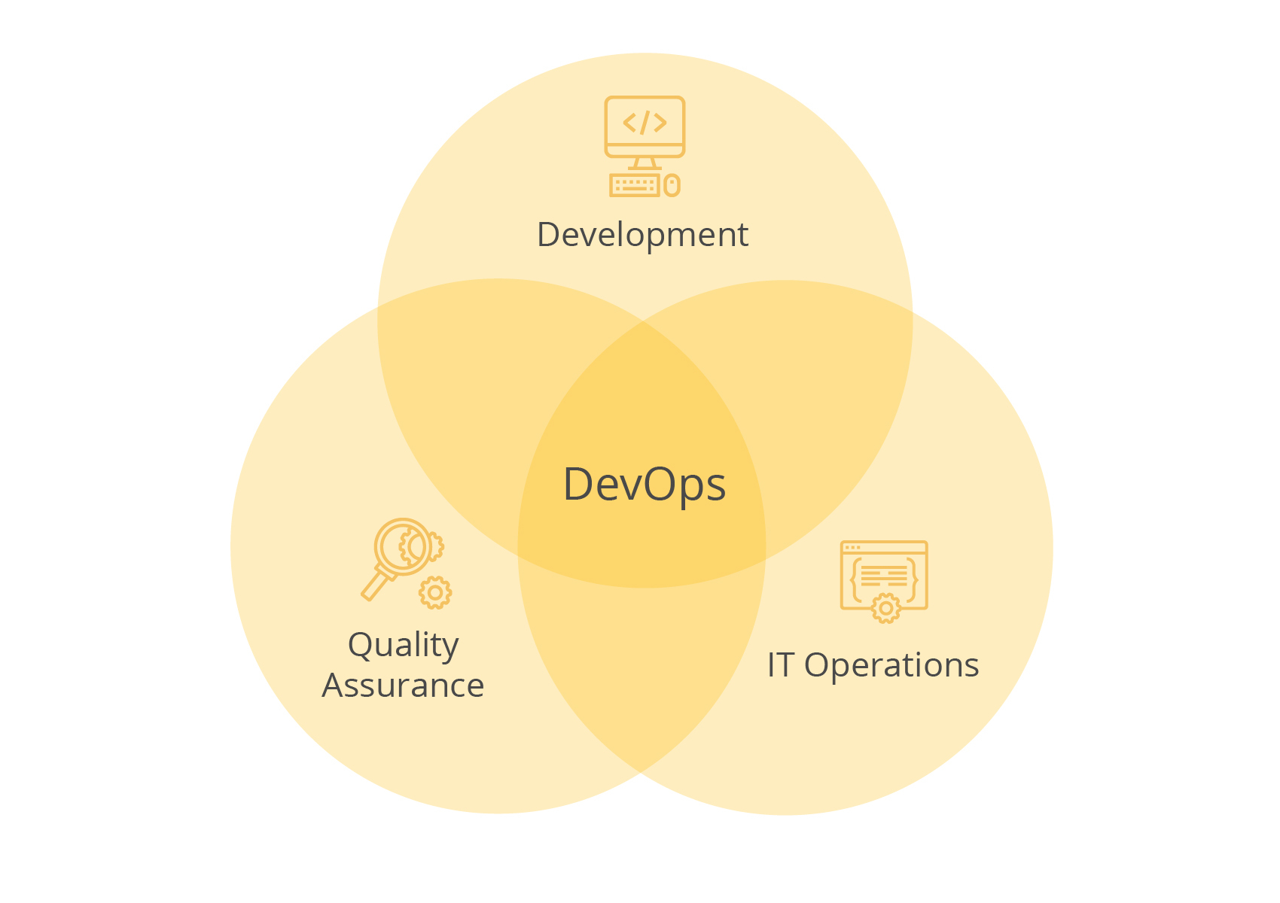
Roles of DevOps:
- Continuous delivery, continuous integration , version control system, Release controls, Analysis & Performance

- Trust, Cross functional report, Continuous communication , Future life cycle, Coordination, Feedback loops.
—-----------------------------------------------------------------------------------------------

8 phases of devops:

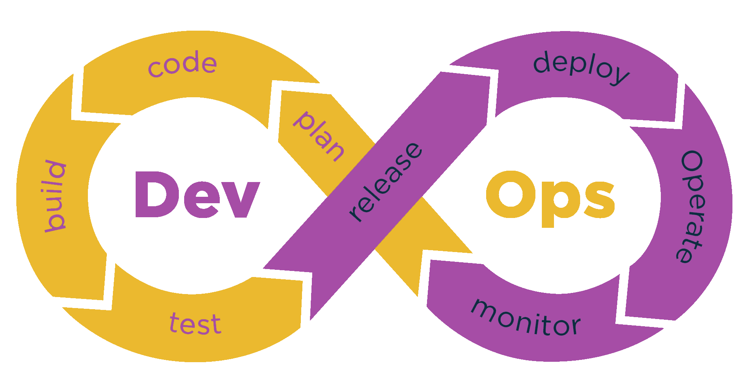
—----------------------------------------------------------------------------------------

What is Gradle?
- It is a build automation tool
- Helps in
- Compiling
- Running Tests
- Packaging (jar/war/docker)
- Deploy and run(Local/On Cloud)
- Before Gradle
- Ant
- Maven
https://en.wikipedia.org/wiki/Gradle
Note: Gradle cannot work without java.
—-----------------------------------------------------------------------------------------------
Convention over Configuration

- Gradle (Like Maven) asks us to follow a folder structure(convention) rather than we defining it (configuration)
- Makes life simple, since every project will have the same folder structure
- My project
- src/main/java
- src/main/resources
- src/test/java
- src/test/resources
- Gradle will always store its file in these directories so that gradle wont get confused finding the files in the system.
—----------------------------------------------------------------------------------------
How Gradles Work?
- Gradle uses Groovy or kotlin scripts for configuration, unlike Maven (which uses XML)
- Called as DSL (Domain Specific Languages)
- The file used for configuration is build.gradle
Note: There is no need to learn Groovy or kotlin scripts and DSL

—-------------------------------------------------------------------------------------------
Incremental Build
- Does not rebuild the whole thing again - makes it very fast
—-------------------------------------------------------------------------------------------
Gradle Installation

- Search for install gradle
- Gradle needs Java 1.8 or higher
- Click on install manually
- 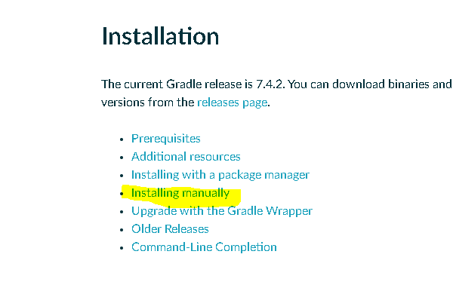
- Download the file(binary)
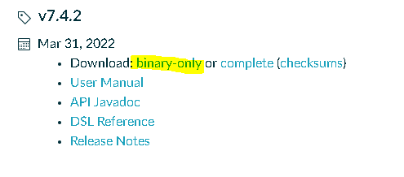
- Extract in your local drive
- Add
- Gradle directory (C:\gradle-7.4.1) to a new variable (environment variable) GRADLE_HOME and
- The bin folder (C:\gradle-7.4.1\bin) to path
- Check gradle version gradle -v on cmd prompt
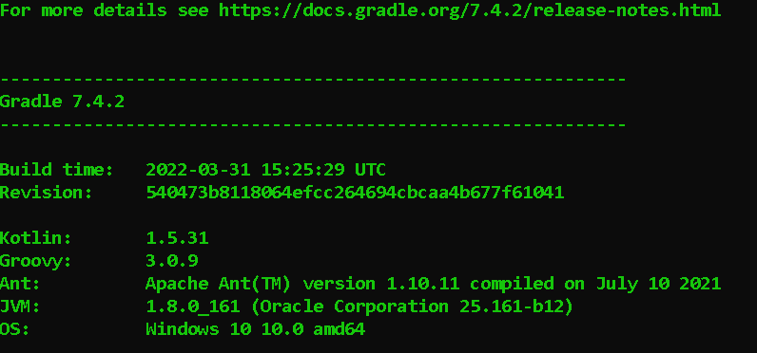

—-------------------------------------------------------------------------------------------

Note: don't create this directory under gradle directory.
Use in cmd >set
=>To see all entries in environment variables

First gradle project
- Create a folder (e.g. C:\code\gradle\firstproject)
- To make this folder a gradle project, we need to add a file build.gradle
- Instead of manually creating this file, open cmd prompt in this folder and type gradle init
- On Win cmd
C:\code\gradle\firstproject>gradle init
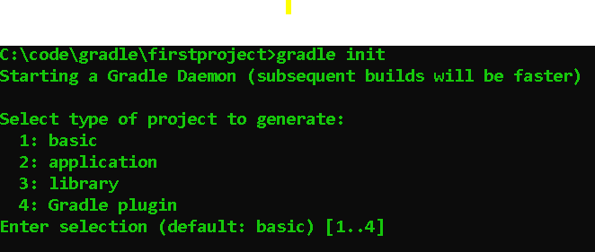
TYPE option 1 to 4
- Select all the defaults and proceed

In that path :C:\code\gradle\firstproject this file will be created
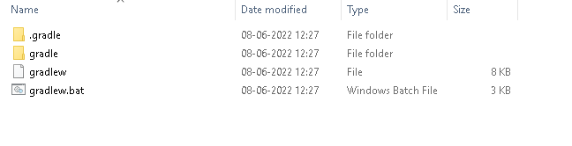
Select default and press enter
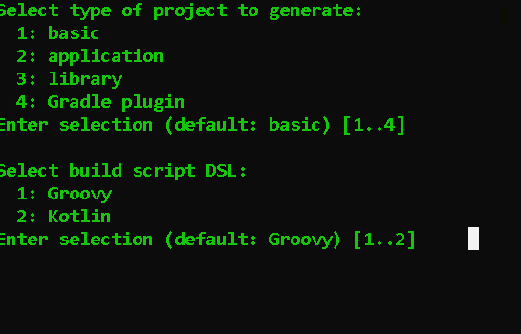
Select default and press enter
Select default and press enter
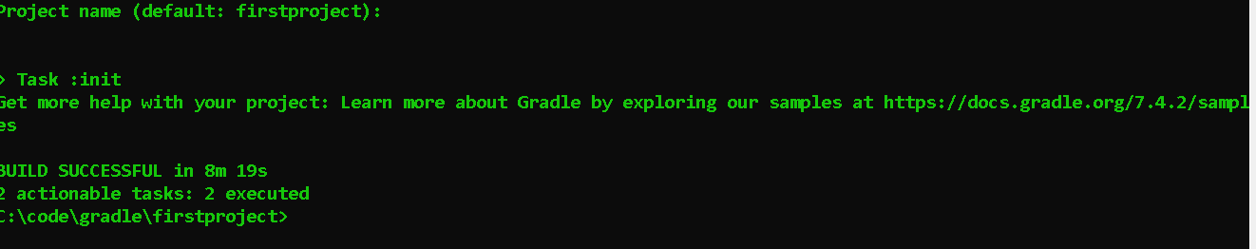

On same Path in cmd : C:\code\gradle\firstproject>gradle task - -all
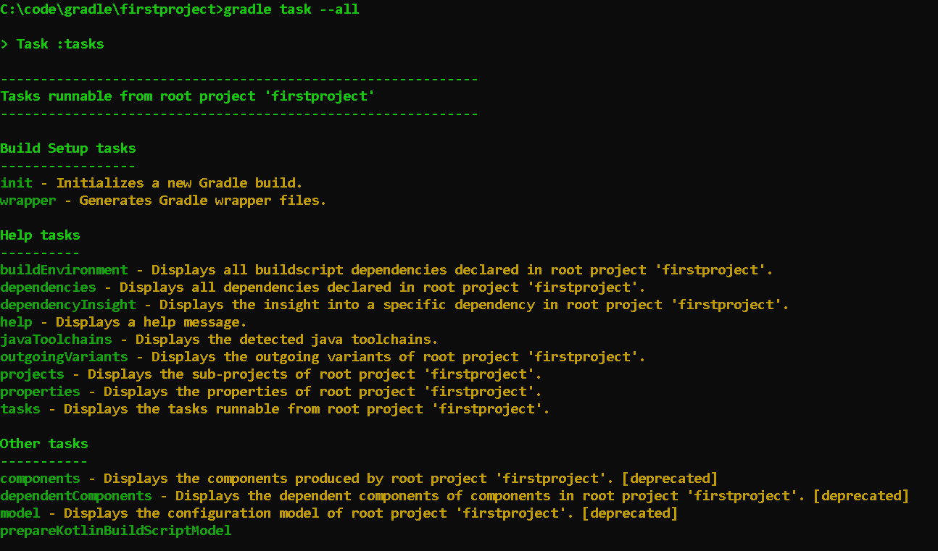

—-----------------------------------------------------------------------------------------------
Now edit build.gradle in notepad present in this path C:\code\gradle\firstproject

- Add task
- task

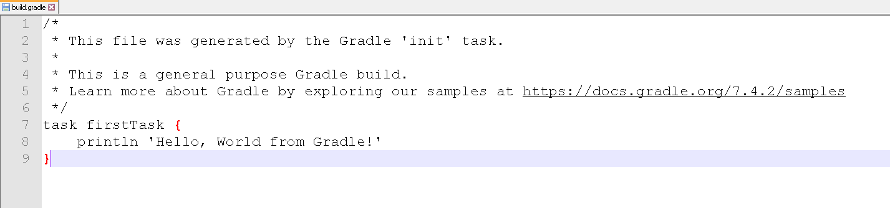
Save it: ctrl+s then run
C:\code\gradle\firstproject>gradle firstTask / gradle fT(always use camel case to run filename in shortform in cmd)
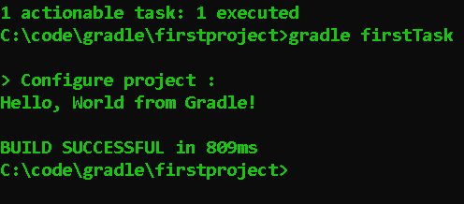

—----------------------------------------------------------------------------------------------- Create a Java Project

Go to folder => C:\code\gradle Create firstJavaProject

Go to cmd => C:\code\gradle\firstJavaProject>gradle init
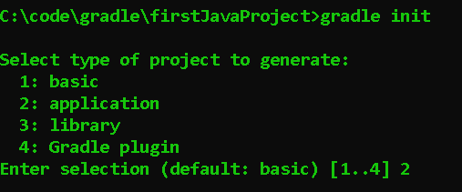
Then Select 2: application
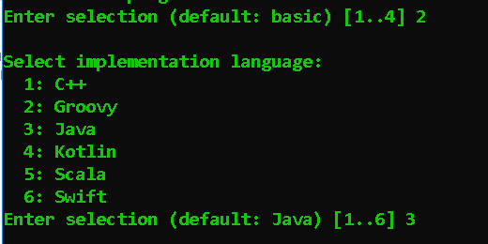
Then Select 3 and select default option for more 2 steps

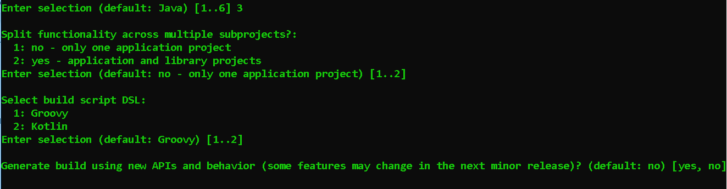
Select framework Select 1 >enter> com.cdac.ditiss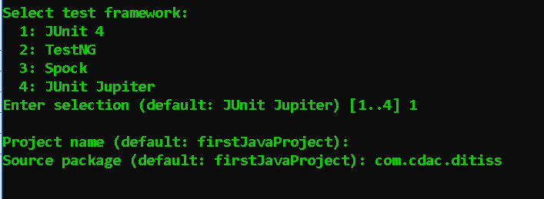
Enter
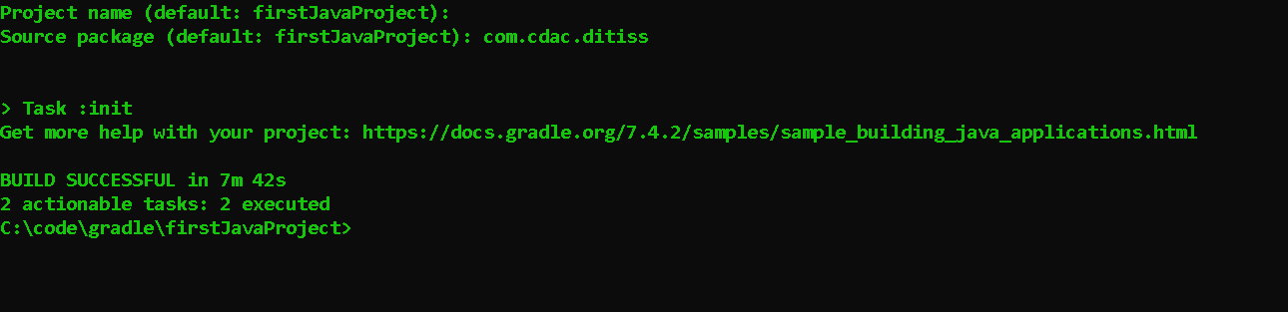
—-----------------------------------------------------------------------------------------------
Go to in win
C:\code\gradle\firstJavaProject\app\src\main\java\com\cdac\ditiss
Open app.java in notepad
Open appTest.java in notepad
Open settings.gradle in notepad

—-----------------------------------------------------------------------------------------------
Build and Run - 1

- On cmd prompt type in firstJavaProject >gradle task –all
- 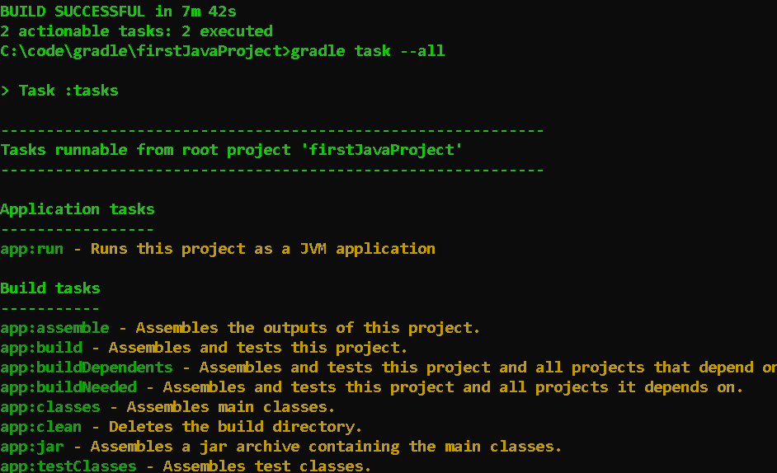
- It will show us all the possible tasks - note that they are different from the earlier non-java project
- Where are they coming from? Open build.gradle file
(C:\code\gradle\firstJavaProject\app)
- The following plugins knows how to build a java application
—-----------------------------------------------------------------------------------------------
Build and Run -2
On cmd
C:\code\gradle\firstJavaProject> gradle compileJava
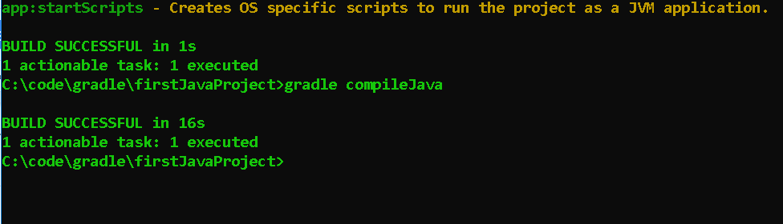
C:\code\gradle\firstJavaProject> gradle run
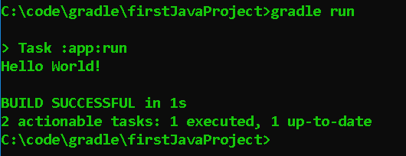

- If we want to do a build again from scratch the use cmd > gradle clean
- gradle clean will clean all the compile code not the original .java file
- I.e . C:\code\gradle\firstJavaProject\app will delete build file

